MINISTRY OF EDUCATION AND SCIENCE OF UKRAINE

NATIONAL TECHNICAL UNIVERSITY   
“KHARKIV POLYTECHNIC INSTITUTE”

Department of Software Engineering and Management Information Technology

REPORT

on laboratory work # 4

on the discipline

“python frameworks”

Executed by

Student of the group KN-218g.e

Karyna OHOL

Checked by

Ass. Prof. of department “SEMIT”

Svitlana KOVALENKO

Kharkiv 2020

Using Pandas for Data Analysis

**Objectives**

**Goal**: Learning main Pandas features for data analysis.

**Tasks**

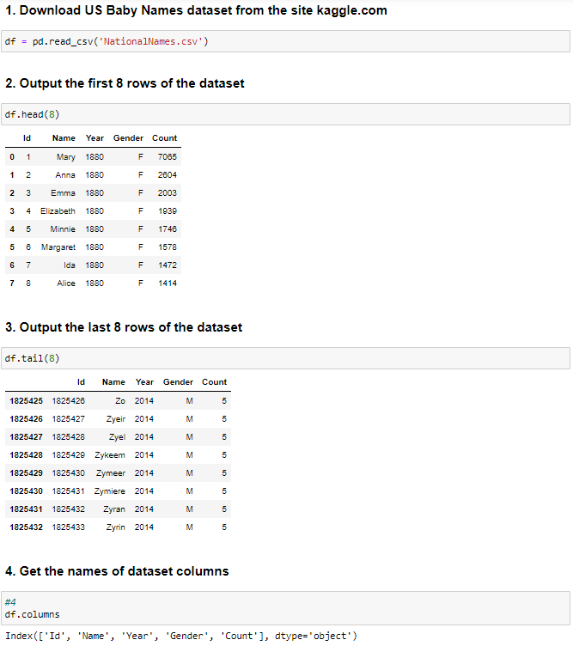

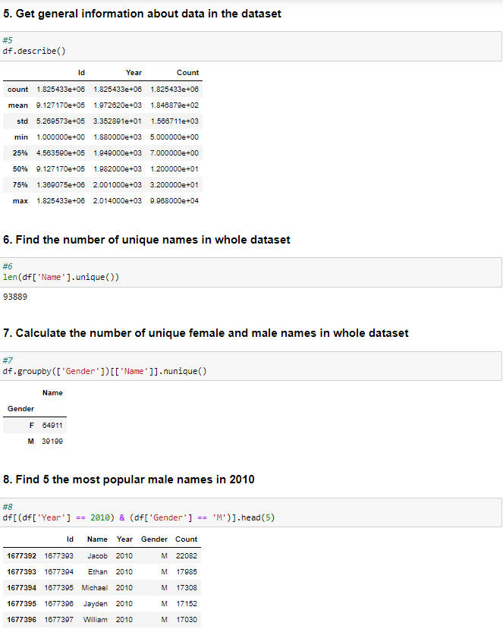

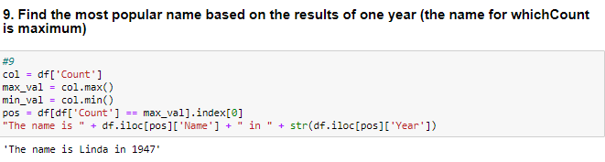

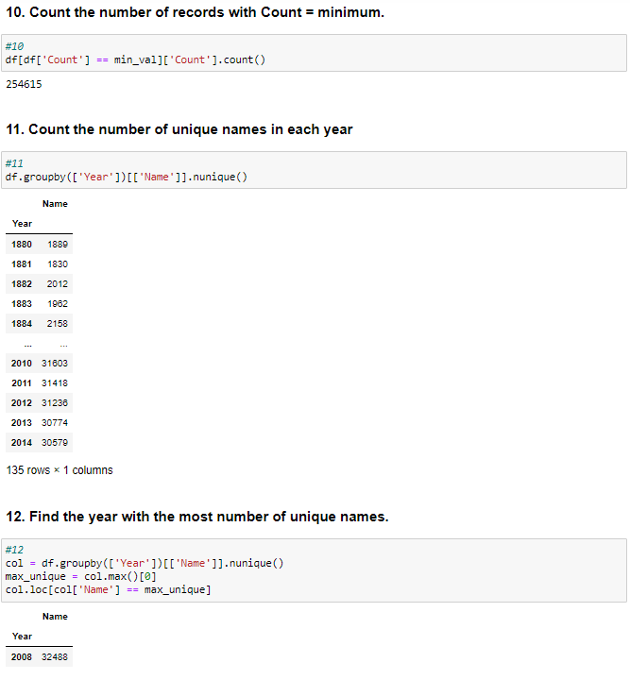

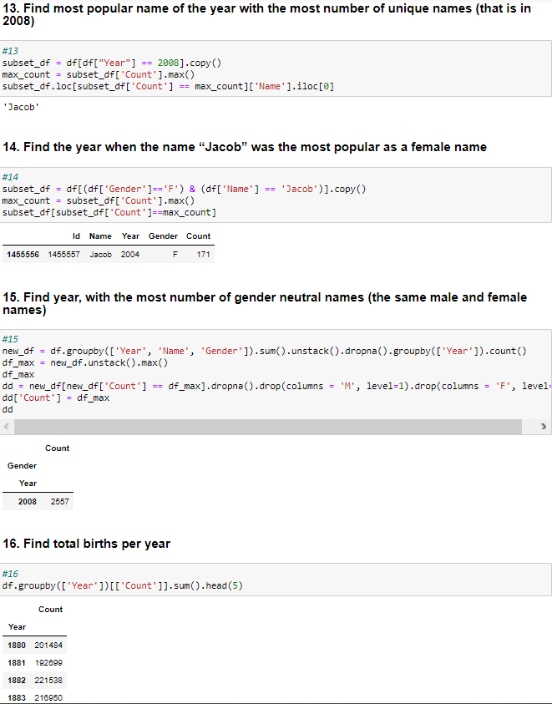

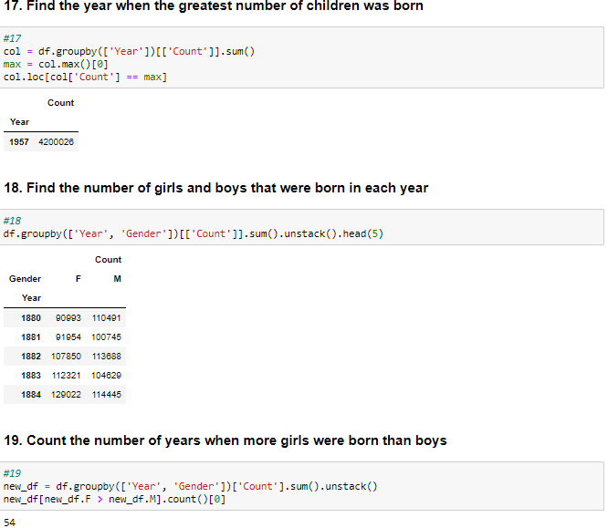

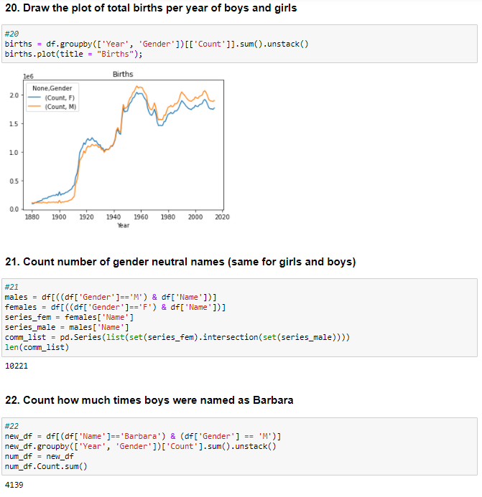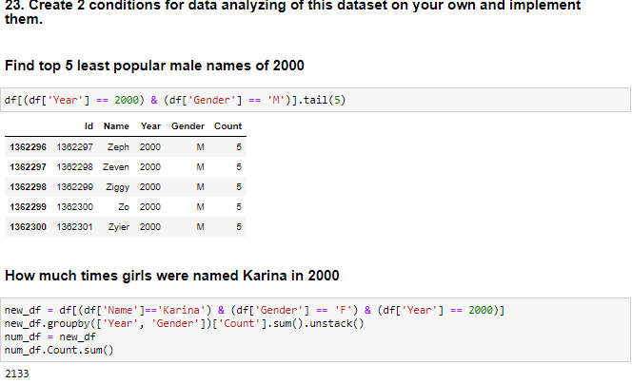

**Conclusions**

To conclude, pandas provide flexible and intuitive way to work with data. For example, it provides powerful filter tools to retrieve data. User is able to search, group, count data and etc.